8-BIT ADDITION USING INDIRECT ADDRESSING

AIM:
To write an assembly language program to add two numbers of 8-bit data stored in memory locations 4200H and 4201H and store the result in 4202H and 4203H using indirect addressing modes
APPARATUS REQUIRED:
- 8085 microprocessor kit 1
- Power card 1
- Keyboard 1

ALGORITHM:
- Load the first data from memory to the accumulator.
- Add the content of Memory to accumulator
- If Carry flag = 0 then jump to step 5
- Increment C register to count the carry
- Store the sum in memory.
- Store the carry in memory from C-register.
- Stop.

Output:
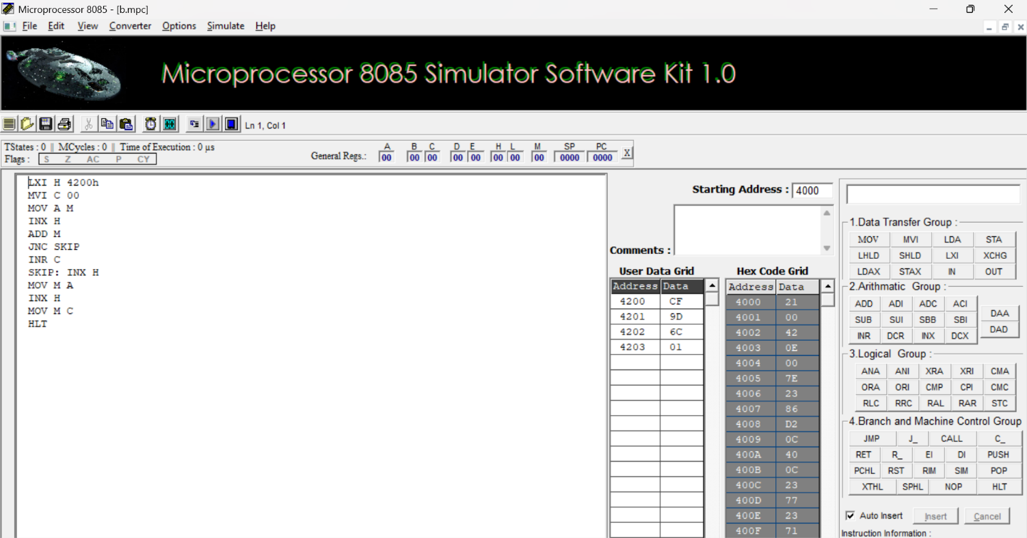

RESULT:
Thus, an assembly language program for addition of two 8-bit numbers with carry was written, executed and Verified the Result successfully using 8085 kit.

